Poornima University: Championing Inclusivity with Special Facilities for Divyangjans
Poornima University, Jaipur, stands as a beacon of inclusive education, where accessibility and equality are core values. The university is committed to creating a campus environment where every student, irrespective of physical challenges, can learn, grow, and thrive with dignity. In line with this commitment, Poornima University has taken proactive measures to ensure that students with disabilities, or Divyangjans, have access to facilities that support their academic and personal needs.
To provide a seamless experience on campus, the university has integrated a range of specially designed infrastructure and services catering to Divyangjans. These efforts are not only a reflection of compliance with accessibility norms but also a manifestation of the university’s deeper dedication to empowerment and inclusion.
Tactile Paths for the Visually Impaired
To support visually impaired students, the university has installed tactile paths throughout the campus. These tactile flooring indicators serve as guiding tracks that help Divyangjan. The tactile paths are constructed in compliance with standard design practices to ensure safety, clarity, and uninterrupted movement.
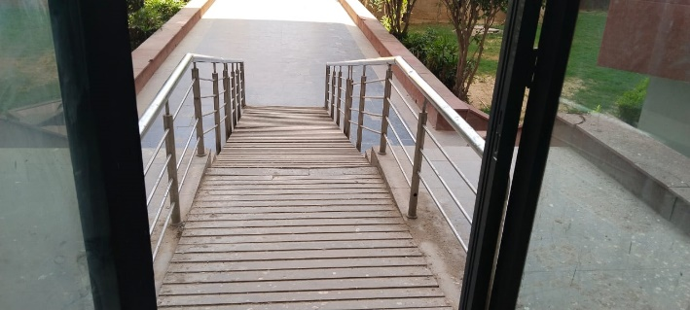
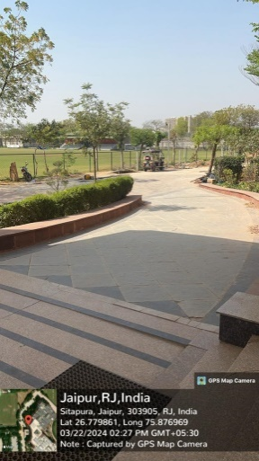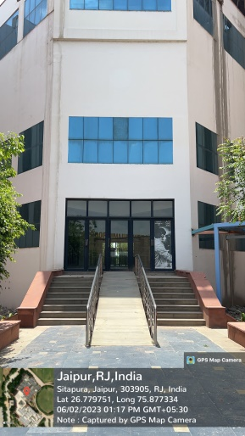
Wheelchair Ramps and Barrier-Free Access
Recognizing the mobility needs of students who use wheelchairs or other assistive devices, Poornima University has implemented barrier-free design principles across its infrastructure. All buildings, including academic blocks are accessible via gently sloped ramps. These ramps connect seamlessly with entrances, elevators, and common areas to enable unrestricted movement within the campus.
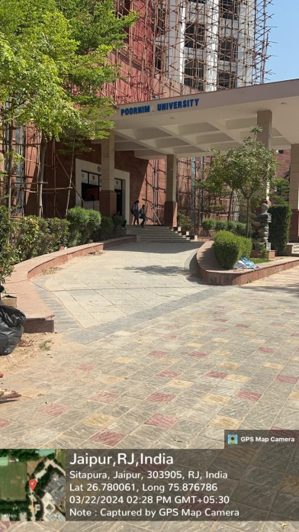
Lifts for Multi-Storey Accessibility
For convenient access to upper floors, the university buildings are equipped with spacious, easy-to-operate elevators. These lifts are designed to accommodate wheelchairs and come with tactile buttons, audio announcements, and emergency support features to ensure a safe and user-friendly experience.
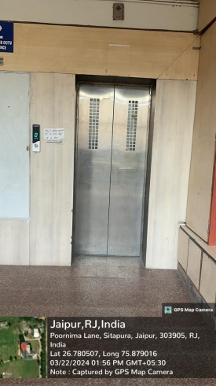

Poornima University takes pride in building a campus that is welcoming, inclusive, and sensitive to the needs of every learner. By integrating infrastructure that supports Divyangjans, the university not only complies with national accessibility mandates but also exemplifies the spirit of equality and opportunity in education.
Specially Designed Washrooms
Understanding the need for personal comfort and independence, Poornima University has constructed special washrooms across the campus. These washrooms are thoughtfully designed with adequate space for wheelchair mobility and are equipped with handrails, non-slippery flooring, and other assistive fixtures to support ease of use and privacy. Their locations are strategically planned in academic blocks, administrative buildings to ensure accessibility at all times.

